Generic Elective – Computer Science  
**Data Structures Using Python   
(Semester-IV)**

**PRACTICAL FILE (2025)**

Lucky Lao  
B.Sc. (H) Mathematics  
23BMAT019

1. Question1

***Code:***

***Output:***

1. Question2

***Code:***

***Output:***

1. Question3

***Code:***

***Output:***

1. Implement stack as an ADT and use it to evaluate a prefix/postfix expression.

***Code-I:***

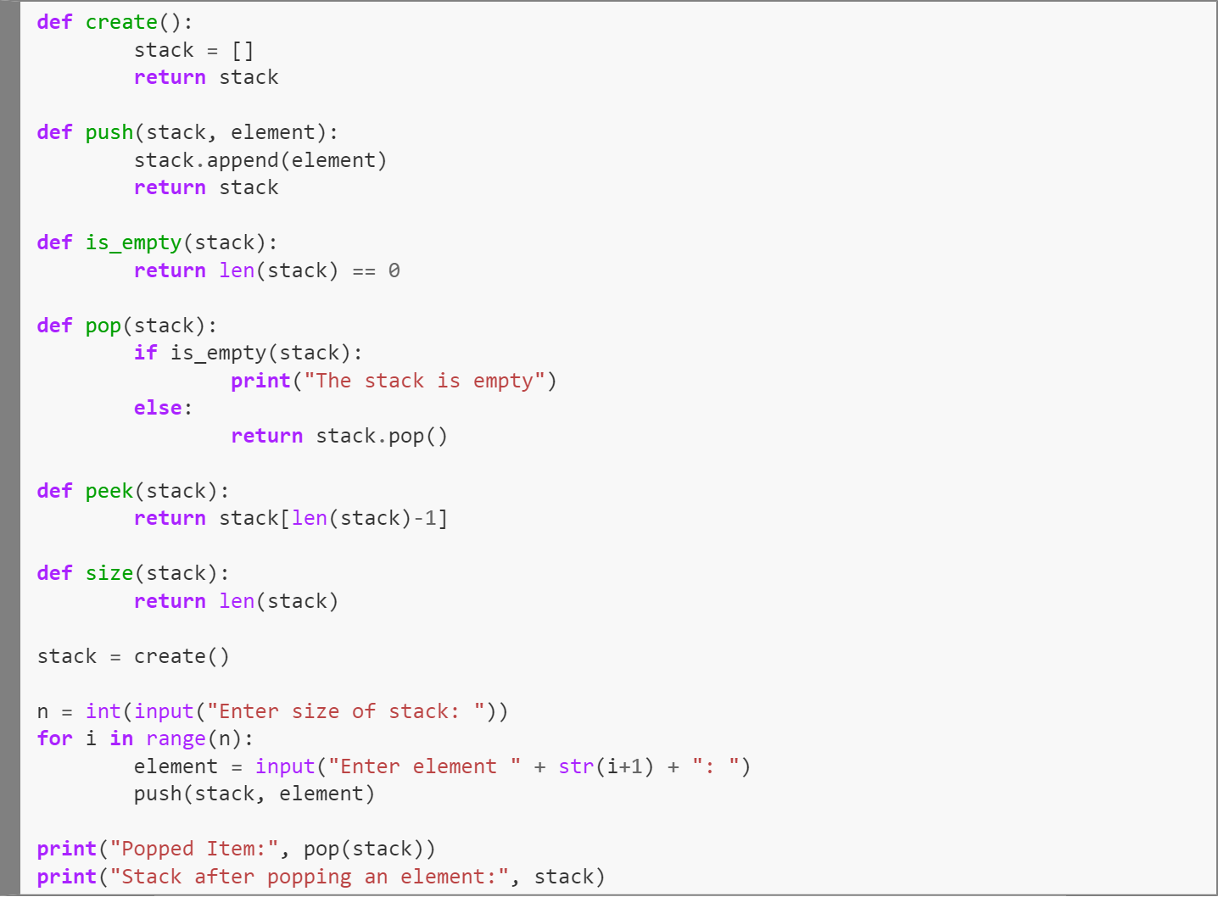

***Output:***

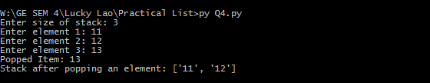

***Code-II (Menu-Driven):***

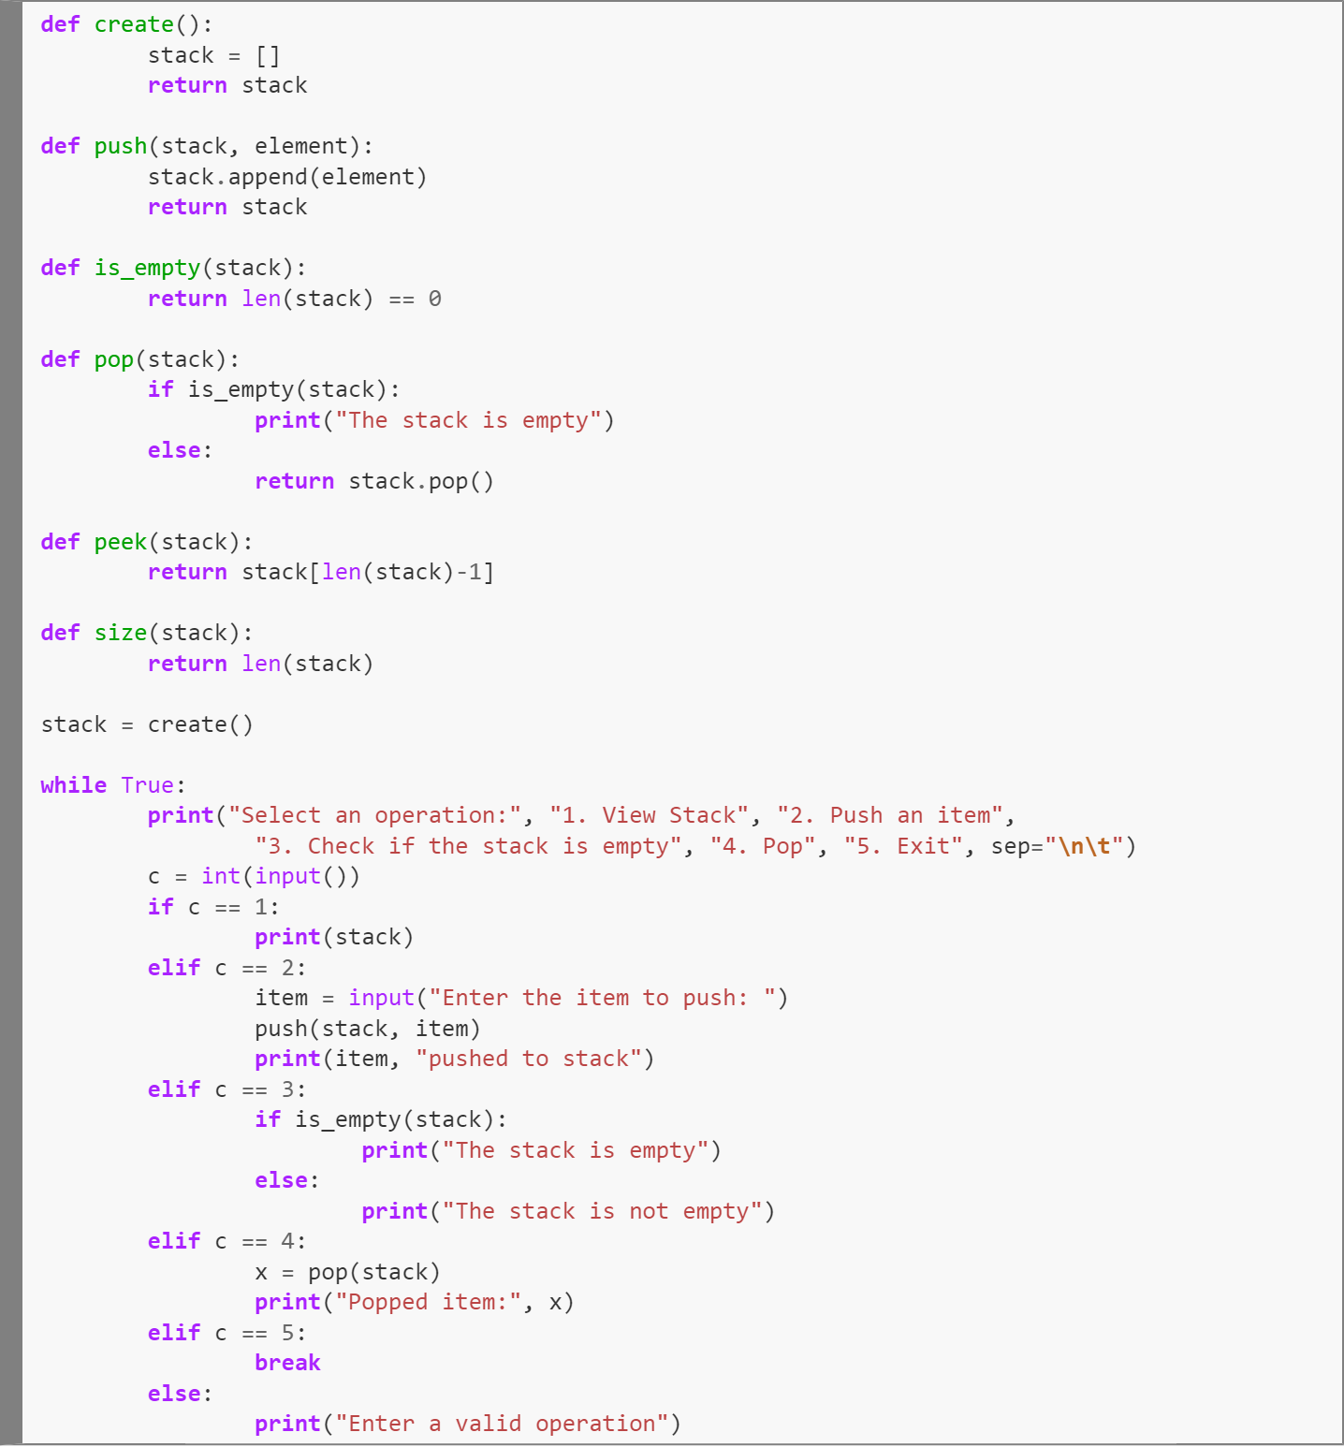

***Output:***

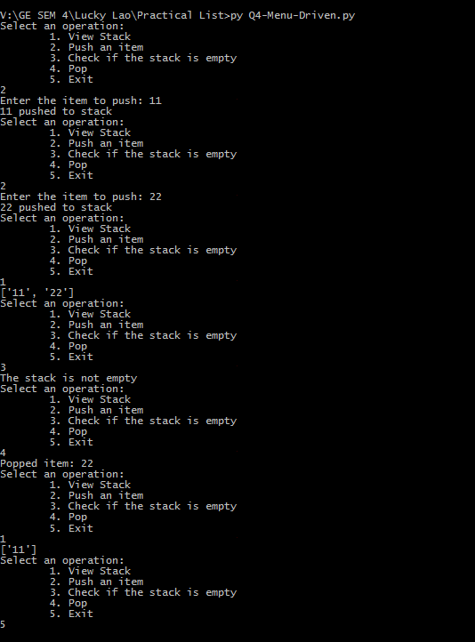

***Code-III (Using class, Menu-Driven):***

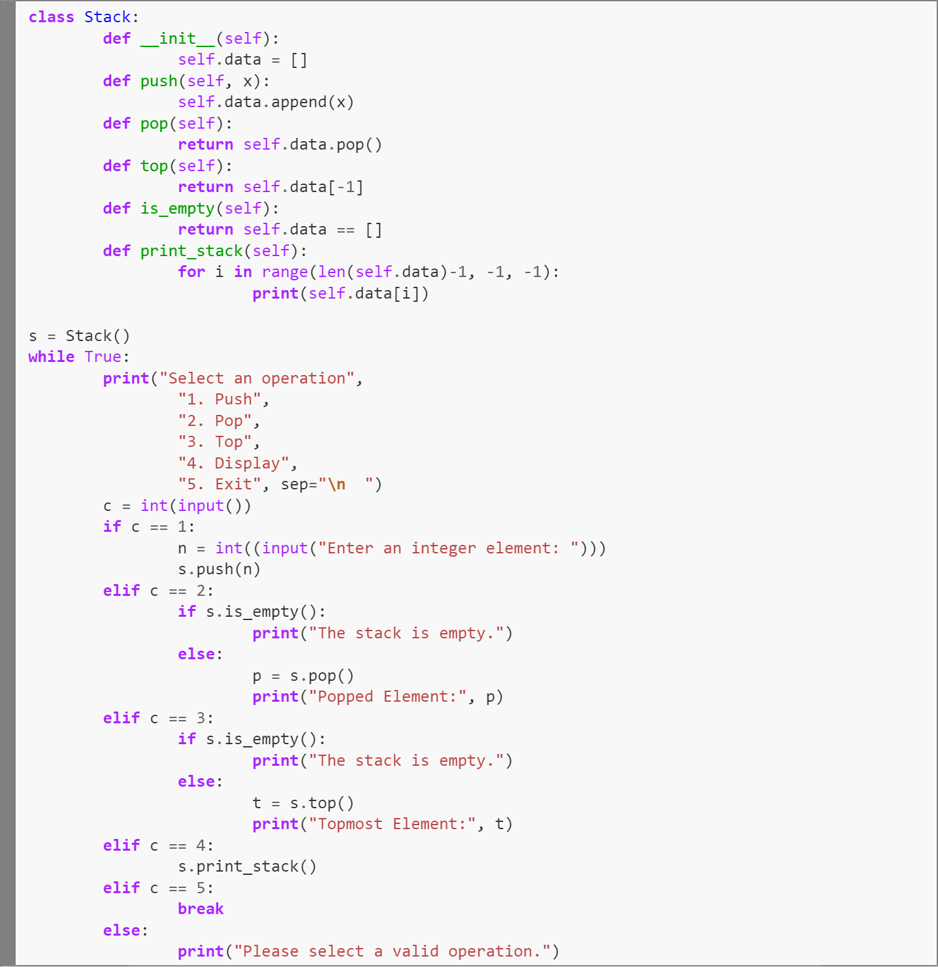

***Output:***

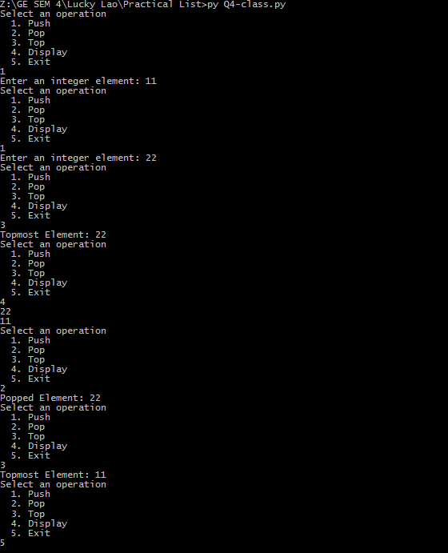

1. Implement Queue as an ADT.

***Code:***

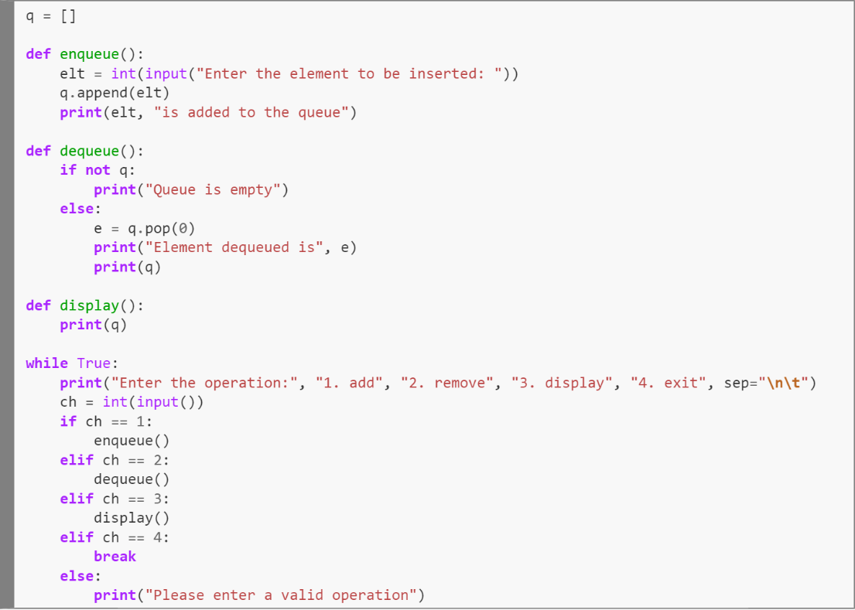

***Output:***

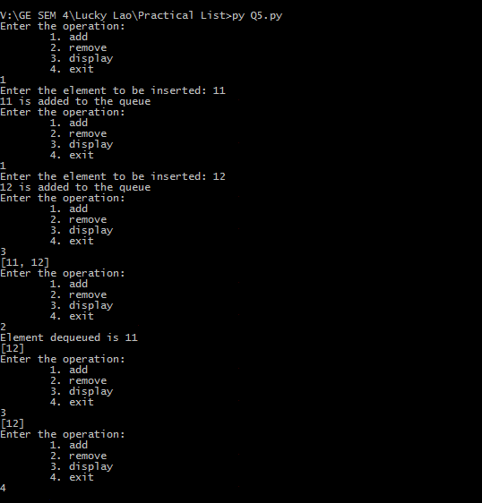

1. Question6

***Code:***

***Output:***

1. Question7

***Code:***

***Output:***